***Library Management System***

***ER Diagram:***

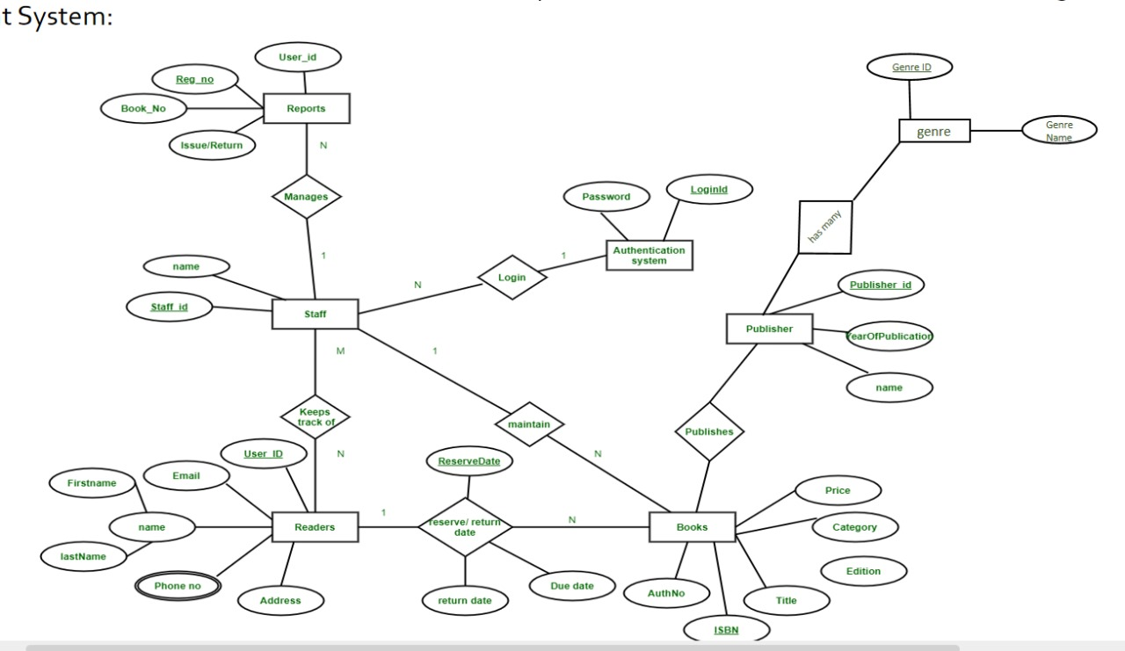

**Age**

**DOB**

***Relational Model:***

|  |  |  |  |
| --- | --- | --- | --- |
| **Reg_No** | **User_ID** | **Book_No** | **Issue/Return** |
|  |  |  |  |
|  |  |  |  |
|  |  |  |  |

*Schema* :- Reports ( Reg_No, User_ID, Book_No, Issue/Return )

|  |  |
| --- | --- |
| **Staff_ID** | **Name** |
|  |  |
|  |  |
|  |  |

*Schema* :- Staff ( Staff_ID, Name )

|  |  |  |  |  |  |  |  |  |
| --- | --- | --- | --- | --- | --- | --- | --- | --- |
| **User_ID** | **FirstName** | **LastName** | **DOB** | **Age** | **Email** | **Phone_No1** | **Phone_No2** | **Address** |
|  |  |  |  |  |  |  |  |  |
|  |  |  |  |  |  |  |  |  |
|  |  |  |  |  |  |  |  |  |

*Schema* :- Readers ( User_ID, FirstName, LastName, DOB, Age, Email, Phone_No1, Phone_No2, Address )

|  |  |  |  |  |  |
| --- | --- | --- | --- | --- | --- |
| **Auth_No** | **ISBN** | **Title** | **Category** | **Edition** | **Price** |
|  |  |  |  |  |  |
|  |  |  |  |  |  |
|  |  |  |  |  |  |

*Schema* :- Books ( Auth_No, ISBN, Title, Category, Edition, Price )

|  |  |
| --- | --- |
| **Login_ID** | **Password** |
|  |  |
|  |  |
|  |  |

*Schema* :- Authentication ( Login_ID, Password )

|  |  |  |
| --- | --- | --- |
| **Publisher_ID** | **Name** | **PublicationYear** |
|  |  |  |
|  |  |  |
|  |  |  |

*Schema* :- Publisher ( Publisher_ID, Name, PublicationYear )

|  |  |
| --- | --- |
| **Genre_ID** | **Name** |
|  |  |
|  |  |
|  |  |

*Schema* :- Genre ( Genre_ID, Name )

|  |  |
| --- | --- |
| **Reg_No** | **Staff_ID** |
|  |  |
|  |  |
|  |  |

*Schema* :- Manages ( Reg_No, Staff_ID )

|  |  |
| --- | --- |
| **Login_ID** | **Staff_ID** |
|  |  |
|  |  |
|  |  |

*Schema* :- Login ( Login_ID, Staff_ID )

|  |  |
| --- | --- |
| **Staff_ID** | **User_ID** |
|  |  |
|  |  |
|  |  |

*Schema* :- Tracks ( Staff_ID, User_ID )

|  |  |
| --- | --- |
| **Staff_ID** | **ISBN** |
|  |  |
|  |  |
|  |  |

*Schema* :- Maintain ( Staff_ID, ISBN )

|  |  |  |  |  |
| --- | --- | --- | --- | --- |
| **User_ID** | **ISBN** | **ReserveDate** | **ReturnDate** | **DueDate** |
|  |  |  |  |  |
|  |  |  |  |  |
|  |  |  |  |  |

*Schema* :- Return ( User_ID, ISBN, ReserveDate, ReturnDate, DueDate )

|  |  |
| --- | --- |
| **Publisher_ID** | **ISBN** |
|  |  |
|  |  |
|  |  |

*Schema* :- Publishes ( Publisher_ID, ISBN )

|  |  |
| --- | --- |
| **Publisher_ID** | **Genre_ID** |
|  |  |
|  |  |
|  |  |

*Schema* :- Types ( Publisher_ID, Genre_ID )